**PIZZA SALES SQL QUERIES**

**A. KPI’s**

**1. Total Revenue:**

select sum(total_price) as Total_Revenue from pizza_sales;

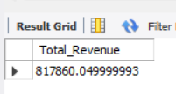

**2. Average Order Value**

select sum(total_price)/count(distinct order_id) as Average_order_Value from pizza_sales;

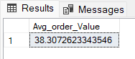

**3. Total Pizzas Sold**

select sum(quantity) as Total_pizza_sold from pizza_sales;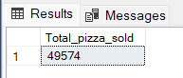

**4. Total Orders**

select count(distinct order_id) as Total_Orders from pizza_sales;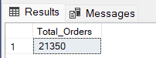

**5. Average Pizzas Per Order**

select cast((sum(quantity)/ count(distinct order_id)) as decimal (10,2)) as Avg_Pizzas_per_order from pizza_sales;

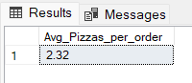

**B. Daily Trend for Total Orders**SELECT DAYNAME(order_date) AS order_day, COUNT(DISTINCT order_id) AS total_orders

FROM pizza_sales

GROUP BY order_day

ORDER BY DAYOFWEEK(MIN(order_date));

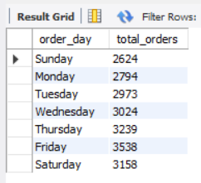

**C. Monthly Trend for Orders**

SELECT MONTHNAME(order_date) AS order_month, COUNT(DISTINCT order_id) AS total_orders

FROM pizza_sales

GROUP BY order_month

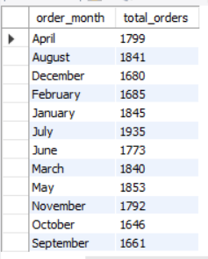

**D. % of Sales by Pizza Category**

SELECT pizza_category AS pizza_Category, CAST(SUM(total_price) as decimal (10,2)) AS Total_Revenue,

CAST(SUM(total_price) * 100 / (SELECT SUM(total_price) from pizza_sales) AS DECIMAL(10,2)) AS PCT

FROM pizza_sales

GROUP BY pizza_Category;

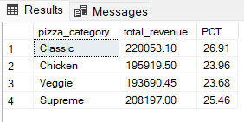

**E. % of Sales by Pizza Size**

SELECT pizza_size AS pizza_Csize, CAST(SUM(total_price) as decimal (10,2)) AS Total_Revenue,

CAST(SUM(total_price) * 100 / (SELECT SUM(total_price) from pizza_sales) AS DECIMAL(10,2)) AS PCT

FROM pizza_sales

GROUP BY pizza_size

ORDER BY PCT DESC;

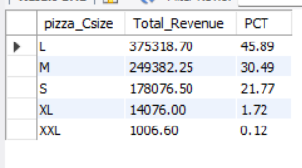

**F. Total Pizzas Sold by Pizza Category**

SELECT pizza_category AS pizza_category, SUM(quantity) as Total_Qty_Sold

FROM pizza_sales

GROUP BY pizza_CATEGORY

ORDER BY Total_Qty_Sold DESC;

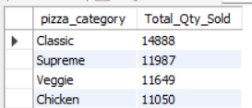

**G. Top 5 Pizzas by Revenue**

SELECT pizza_name, SUM(total_price) AS Total_Revenue

FROM pizza_sales

GROUP BY pizza_name

ORDER BY Total_Revenue DESC

LIMIT 5;

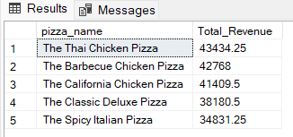

**H. Bottom 5 Pizzas by Revenue**

SELECT pizza_name, SUM(total_price) AS Total_Revenue

FROM pizza_sales

GROUP BY pizza_name

ORDER BY Total_Revenue

LIMIT 5;

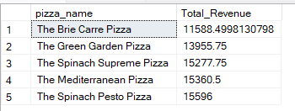

**I. Top 5 Pizzas by Quantity**

SELECT pizza_name, SUM(quantity) AS Total_Pizza_Sold

FROM pizza_sales

GROUP BY pizza_name

ORDER BY Total_Pizza_Sold DESC

LIMIT 5;

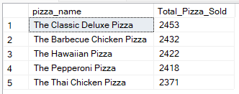

**J. Bottom 5 Pizzas by Quantity**

SELECT pizza_name, SUM(quantity) AS Total_Pizza_Sold

FROM pizza_sales

GROUP BY pizza_name

ORDER BY Total_Pizza_Sold

LIMIT 5;

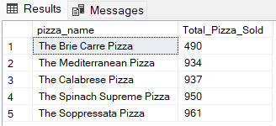

**K. Top 5 Pizzas by Total Orders**

SELECT pizza_name as pizza_name, COUNT(DISTINCT order_id) AS Total_Orders

FROM pizza_sales

GROUP BY pizza_name

ORDER BY Total_Orders DESC

limit 5;

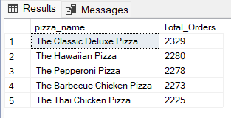

**L. Borrom 5 Pizzas by Total Orders**

SELECT pizza_name as pizza_name, COUNT(DISTINCT order_id) AS Total_Orders

FROM pizza_sales

GROUP BY pizza_name

ORDER BY Total_Orders

limit 5;

